How java code runs?

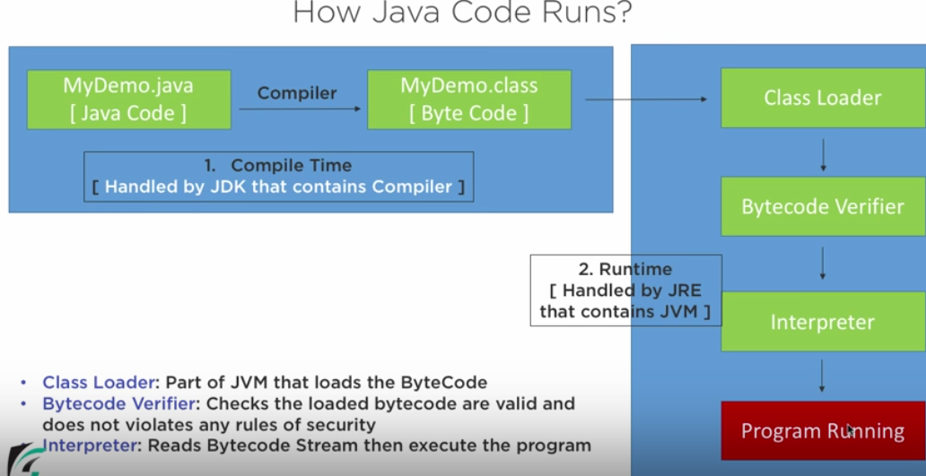

Using the compiler which is part of JDK, java code will be converted as bytecode which JVM can understand.

Byte code is simplified version of java code which JVM can understand. This process of converting java code to byte code is nothing but “compilation”.

**Class loader:**  Will load the bytecode into the memory.

**Bytecode verifier:** To verify, if the loaded bytecode is valid or not.

**Interpreter:** Reads the code line by line and execute the program.